Moduldokumentation

Modul Functional Programming (fprog)

Simon Wächter

2016

Inhalt

1 Einleitung 3

1.1 Einleitung 3

1.2 Lernziele 3

1.3 Prüfungen 3

2 Woche 1 4

2.1 What is a Functional Language 4

2.2 Example 4

2.3 History 4

2.4 Glasgow Haskell Compiler 4

2.5 Prelude 4

2.6 Examples 5

2.7 Function Application 5

2.8 Examples 6

2.9 Haskell Scripts 6

2.10 GHCI Commands 6

2.11 Name Requirements 7

2.12 Layout Rule 7

3 Woche 2 8

3.1 What is a Function? 8

3.2 What is a Partial Function? 10

3.3 Domain of Definition 10

3.4 Confusion 10

3.5 Additional types 11

3.6 Summary 11

4 Woche 3 12

4.1 What is a Type 12

4.2 Type Errors 12

4.3 Types in Haskell 12

4.4 Basic Types 13

4.5 List Types 13

4.6 Tuple Types 14

4.7 Function Types 15

4.8 Curried Functions 15

4.9 Why is Currying useful 16

4.10 Currying Conventions 17

4.11 Polymorphic Functions 17

4.12 Overloaded Functions 18

4.13 Hints and Tips 19

5 Woche 4 20

5.1 Typeclasses 20

6 Woche 5 21

6.1 Conditional Expressions 21

6.2 Guarded Equations 21

6.3 Pattern Matching 22

6.4 List Patterns 23

7 Woche 6 25

7.1 Lambda Expressions 25

7.2 Why are Lambdas useful 25

7.3 Operator Sections 27

7.4 Why are Sections useful 27

7.5 Set Comprehensions 28

7.6 List Comprehensions 28

7.7 Dependent Generators 29

7.8 Guards 30

8 Woche 7 32

8.1 Zip Function 32

8.2 String Comparison 33

9 Woche 8 35

10 Woche 9 & 10 36

10.1 Introduction to Recursion 36

10.2 Recursive Functions 36

10.3 Why is Recursion useful 37

10.4 Recursion on Lists 38

10.5 Multiple Arguments 40

10.6 Quicksort 40

11 Woche 11 42

12 Woche 12 43

# Einleitung

## Einleitung

Dieses Dokument stellt die Moduldokumentation für das Modul fprog dar. Allfällige Unterlagen sind im Modulordner zu finden.

## Lernziele

Das Modul beinhaltet folgende Lernziele:

* Sinn der funktionalen Programmierung
* Anwenden der funktionalen Programmierung

## Prüfungen

Die Modulnote setzt sich zu 100% aus zwei Semesterprüfungen zu 50 % zusammen.

# Woche 1

## What is a Functional Language

Opinions differ, and it is difficult to give a precise definition, but generally speaking:

* Functional programming is **style** of programming in which the basic method of computation is the application of functions to arguments;
* A functional language is one that **supports** and **encourages** the functional style.

## Example

Summing the integers 1 to 10 in Java (The computation method is **variable assignment**):

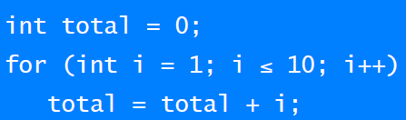

Summing the integer 1 to 10 in Haskell (The computation method is **function application**):



## History

* 1930s: Alonzo Church develops the lambda calculus, a simple but powerful theory of functions.
* 1950s: John McCarthy develops Lisp, the first functional language, with some influences from the lambda calculus, but retaining variable assignments.
* 1960s: Peter Landin develops ISWIM, the first pure functional language, based strongly on the lambda calculus, with no assignments.
* 1970s: John Backus develops FP, a functional language that emphasizes higher-order functions and reasoning about programs.
* 1970s: Robin Milner and others develop ML, the first modern functional language, which introduced type inference and polymorphic types.
* 1970s – 1980s: David Turner develops a number of lazy functional languages, culminating in the Miranda system.
* 1987: An international committee starts the development of Haskell, a standard lazy functional language.
* 1990s: Phil Wadler and others develop type classes and monads, two of the main innovations of Haskell.
* 2003: The committee publishes the Haskell Report, defining a stable version of the language; an updated version was published in 2010.
* 2010 – today: Haskell Platform - Standard distribution, library support, new language features, development tools, use in industry, influence on other languages, etc.

## Glasgow Haskell Compiler

* GHC is the leading implementation of Haskell, and comprises a compiler and interpreter;
* The interactive nature of the interpreter makes it well suited for teaching and prototyping;
* GHC is freely available from the Haskell website;

## Prelude

* Haskell comes with a large number of standard library functions. In addition to the familiar numeric functions such as + and *, the library also provides many useful functions on lists.

## Examples

* Select the first element of a list: head [1,2,3,4,5] 🡪 1
* Remove the first element of a list: tail [1,2,3,4,5] 🡪 [2,3,4,5]
* Select the nth element of a list: [1,2,3,4,5] !! 2 🡪 3
* Select the first n elements of a list: take 3 [1,2,3,4,5] 🡪 [1,2,3]
* Remove the first n elements from a list: drop 3 [1,2,3,4,5] 🡪 [4,5]
* Calculate the length of a list: length [1,2,3,4,5] 🡪 5
* Calculate the sum of a list of numbers: sum [1,2,3,4,5] 🡪 15
* Calculate the product of a list of numbers: product [1,2,3,4,5] 🡪 120
* Append two lists: [1,2,3] ++ [4,5] 🡪 [1,2,3,4,5]
* Reverse a list: reverse [1,2,3,4,5] 🡪 [5,4,3,2,1]

## Function Application

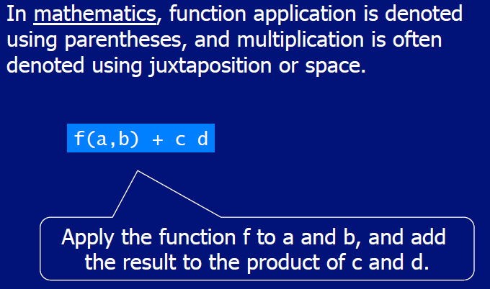

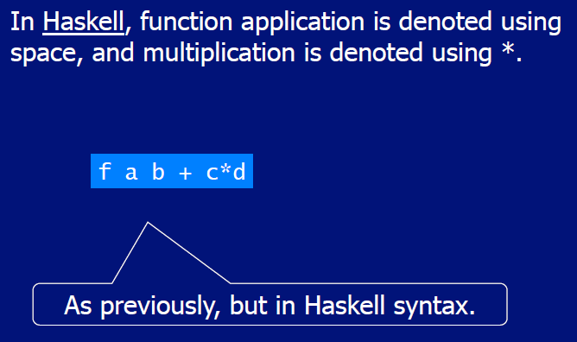

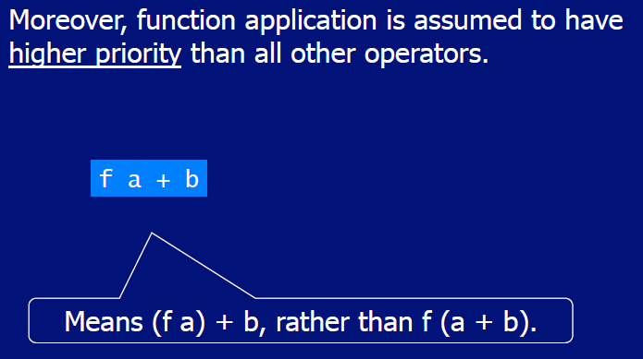

## Examples

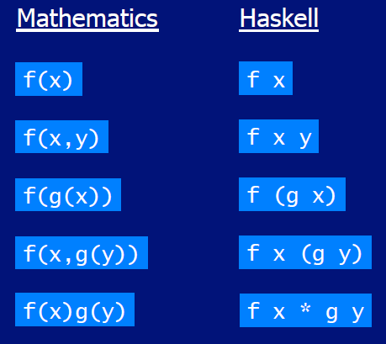

## Haskell Scripts

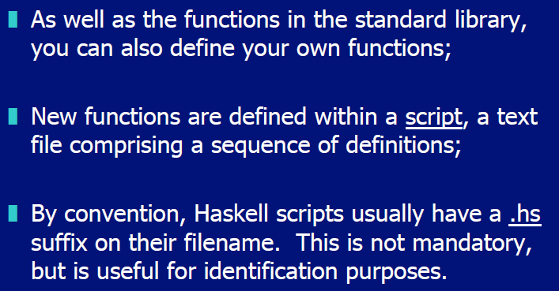

## GHCI Commands

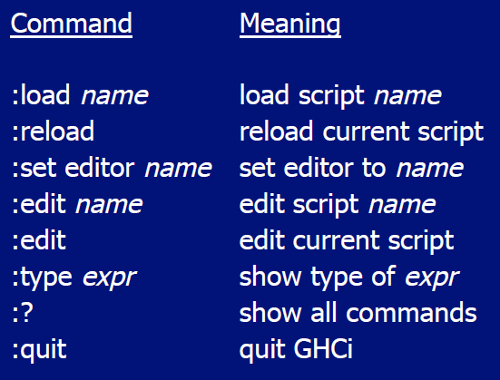

## Name Requirements

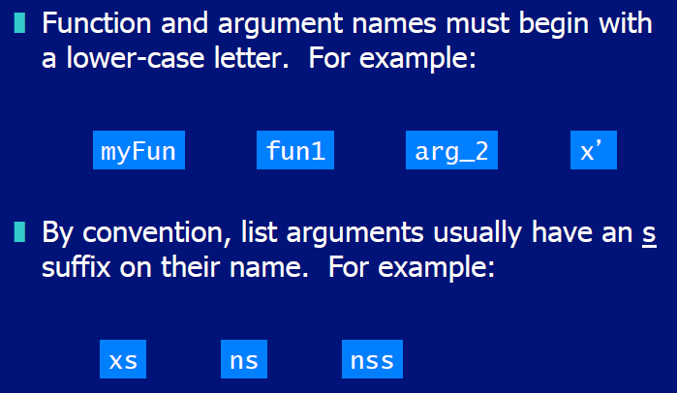

## Layout Rule

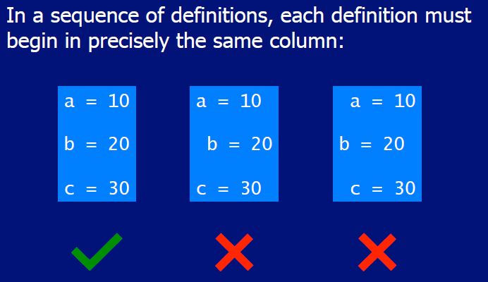

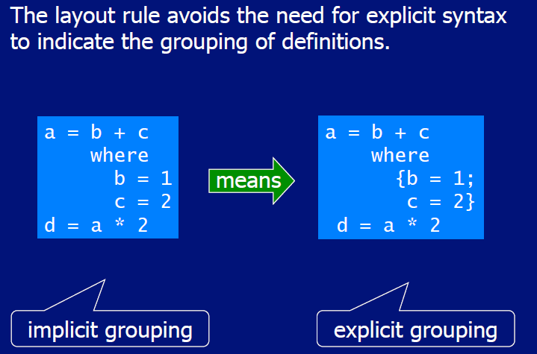

# Woche 2

## What is a Function?

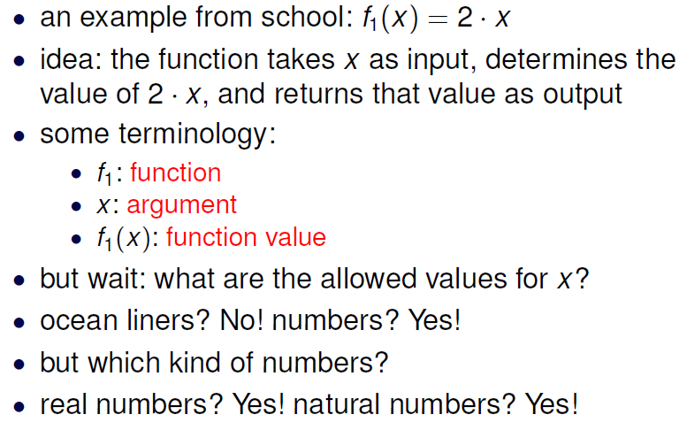

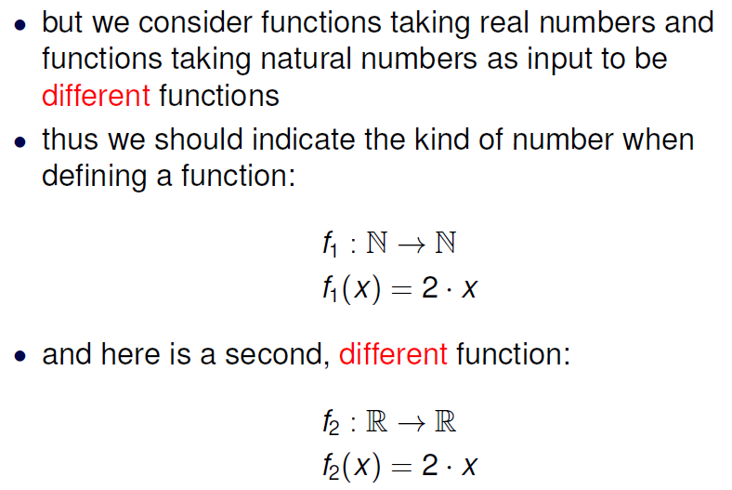

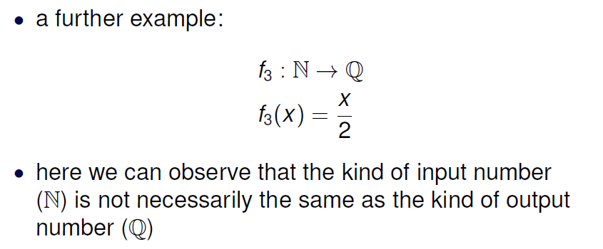

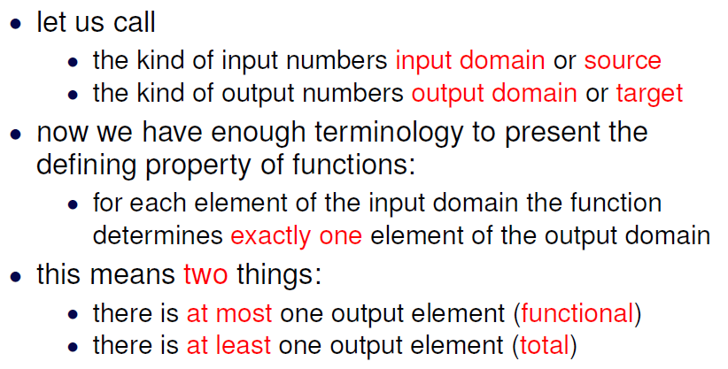

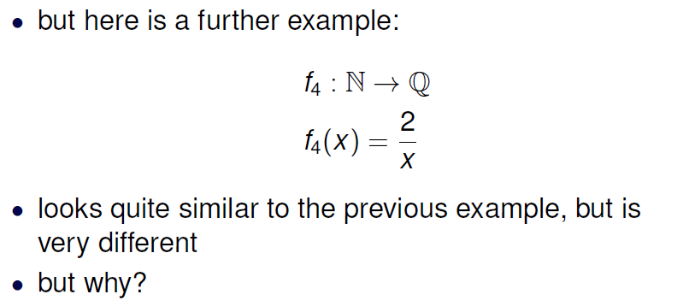

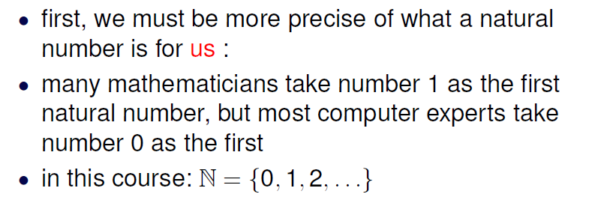

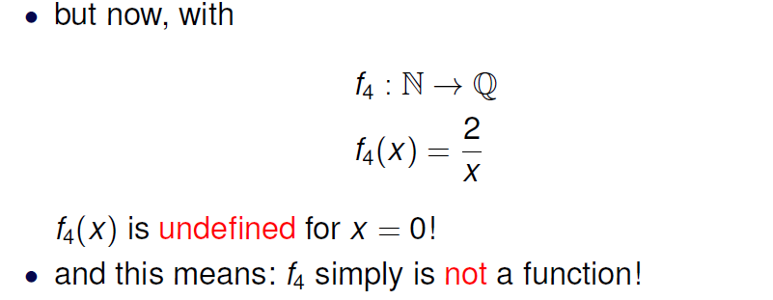

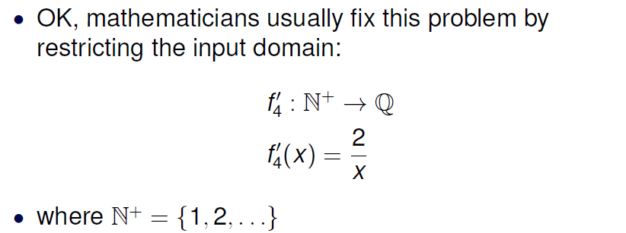

## What is a Partial Function?

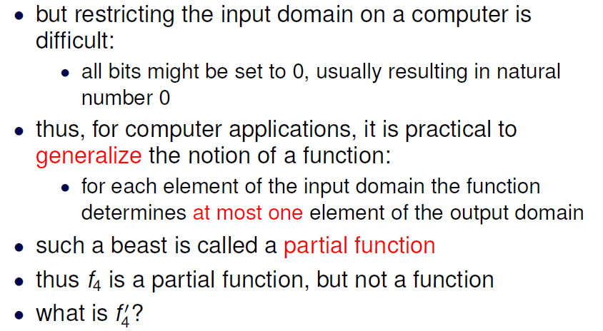

## Domain of Definition

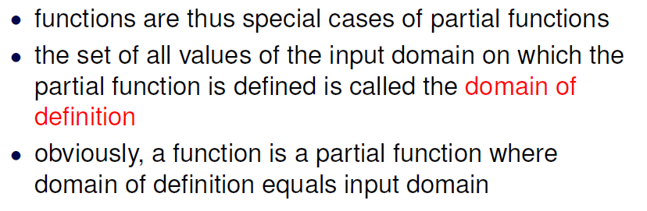

## Confusion

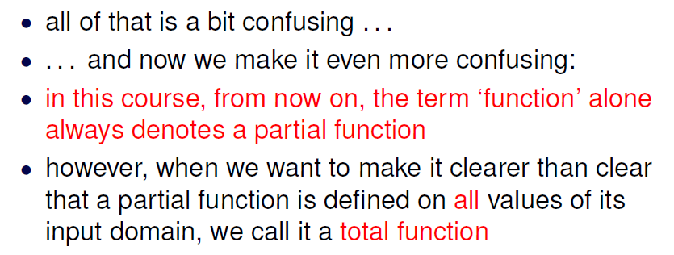

## Additional types

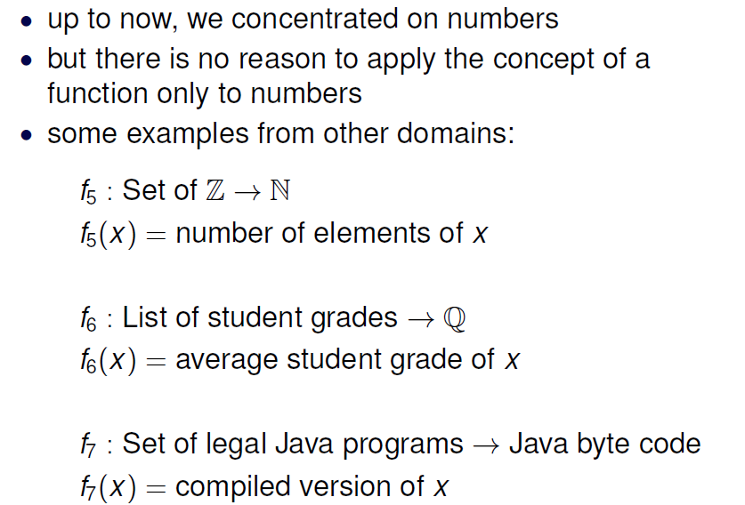

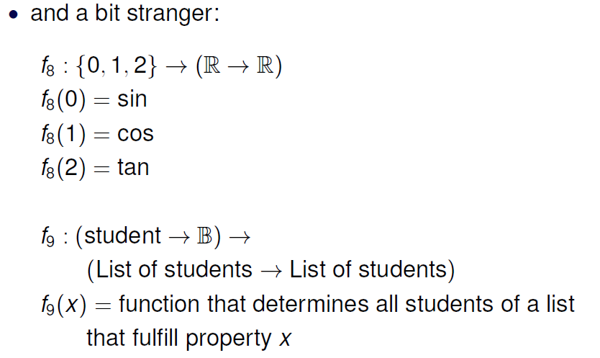

## Summary

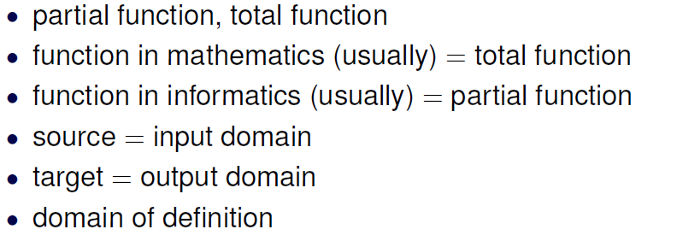

# Woche 3

## What is a Type

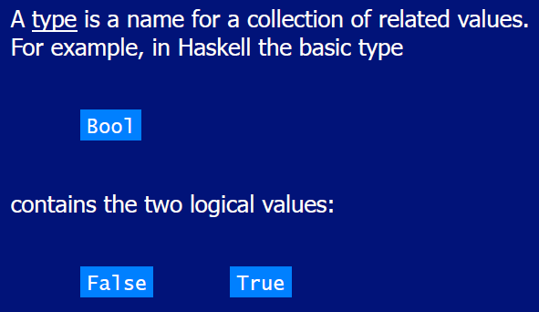

## Type Errors

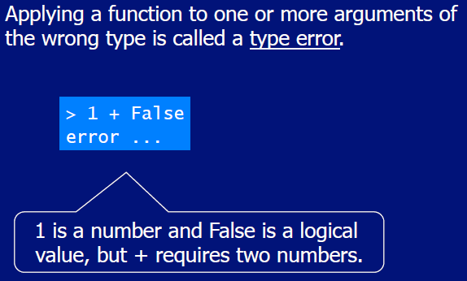

## Types in Haskell

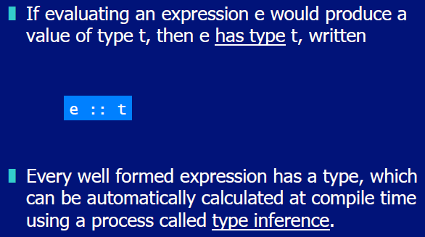

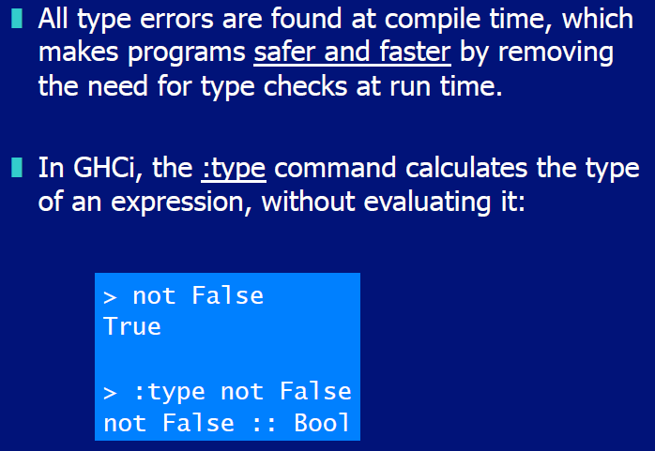

## Basic Types

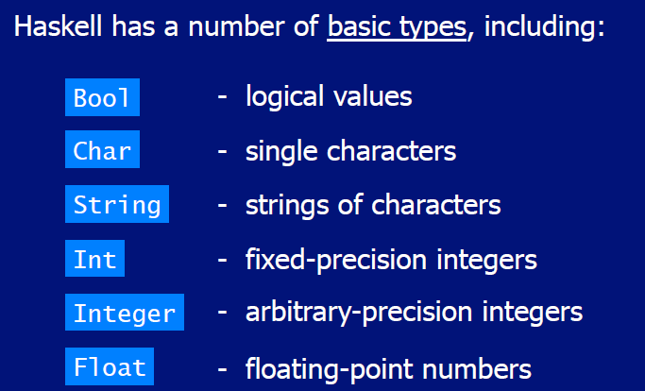

## List Types

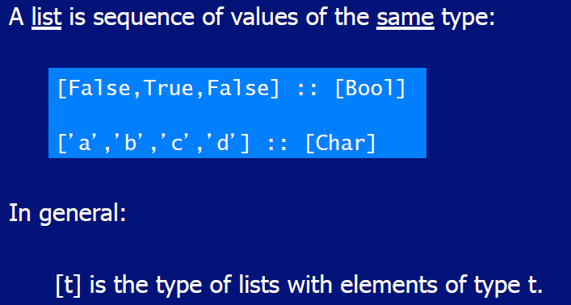

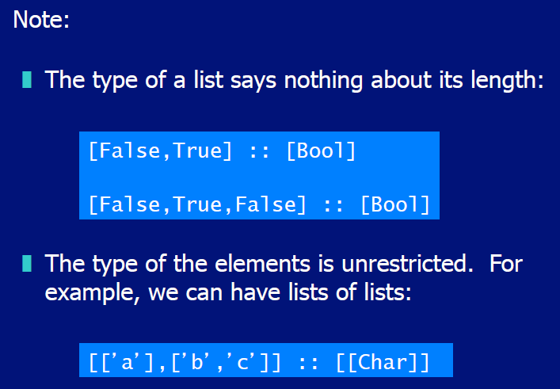

## Tuple Types

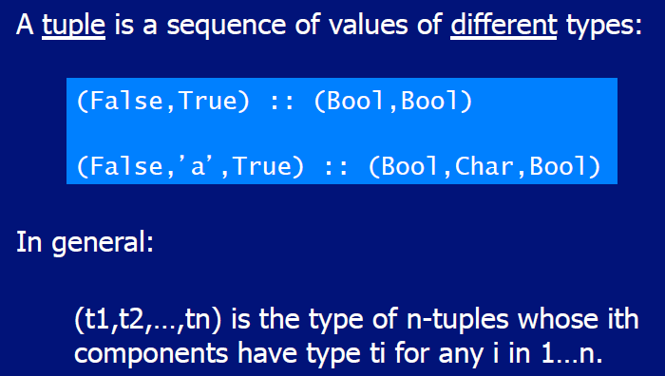

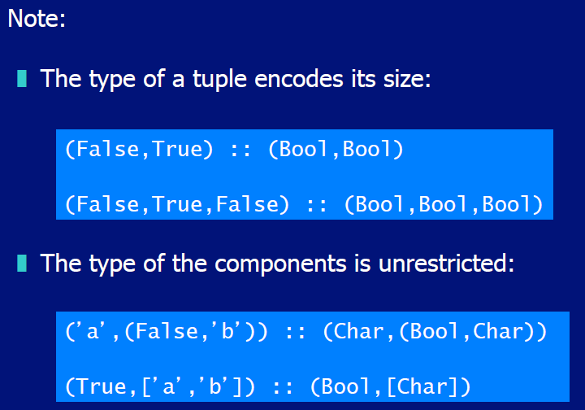

## Function Types

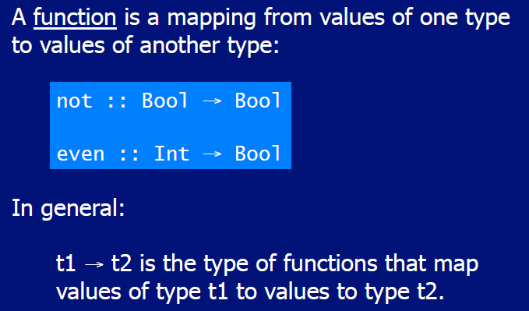

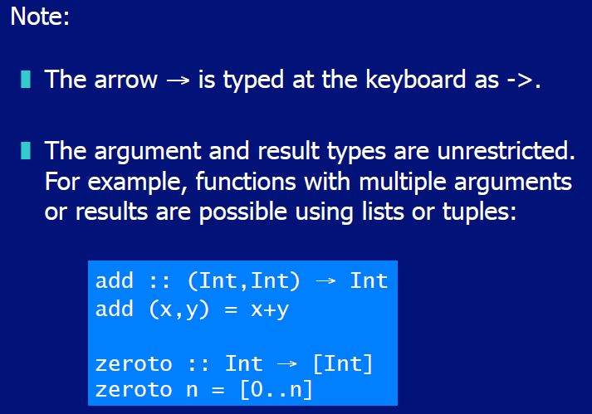

## Curried Functions

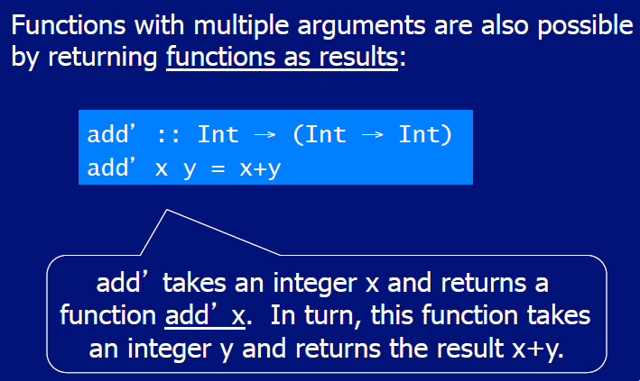

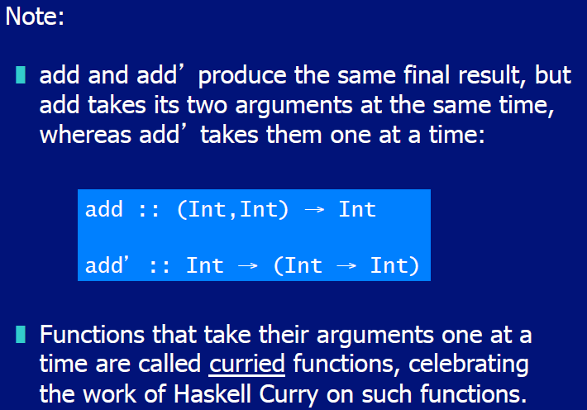

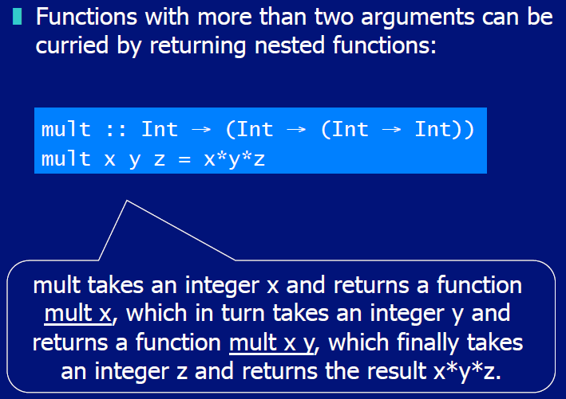

## Why is Currying useful

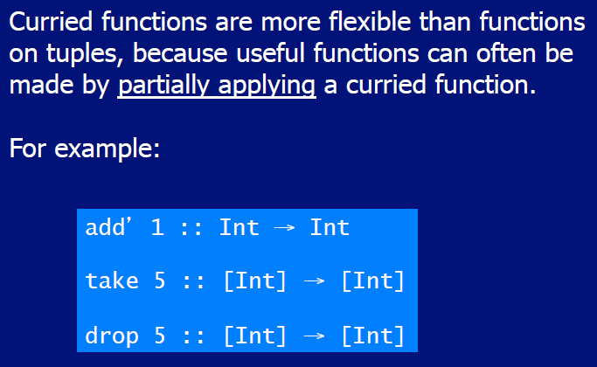

## Currying Conventions

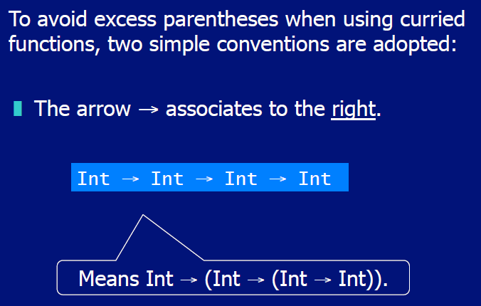

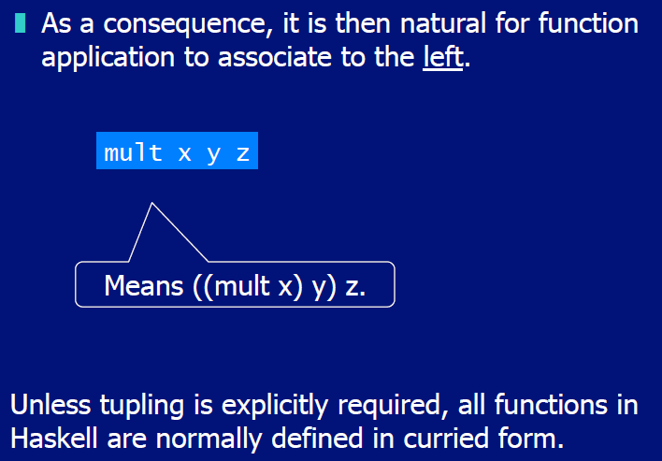

## Polymorphic Functions

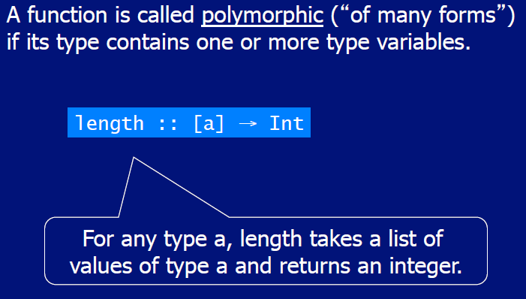

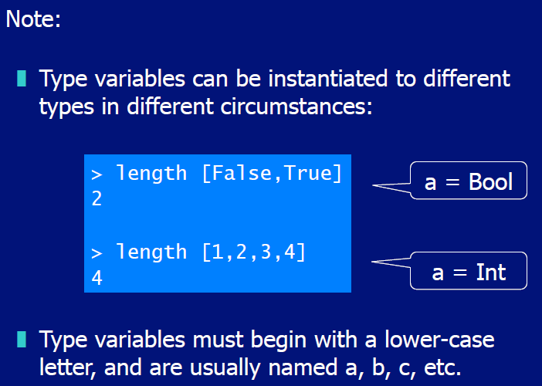

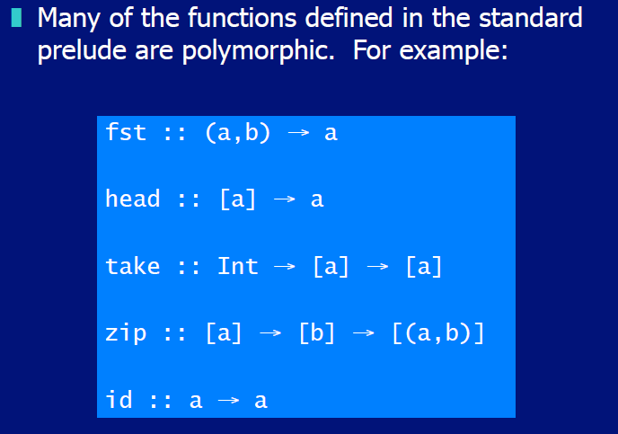

## Overloaded Functions

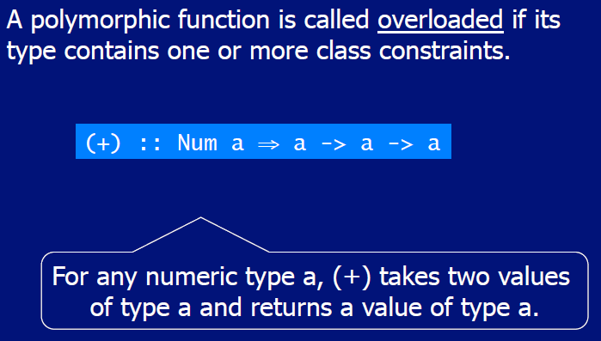

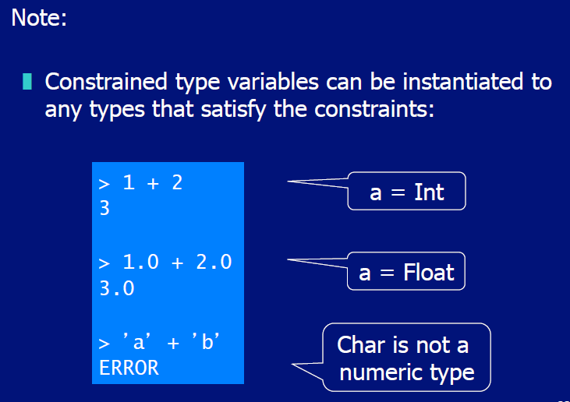

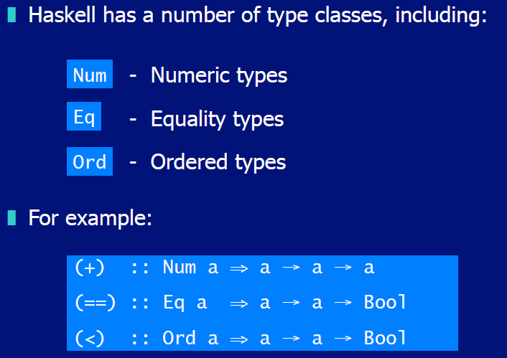

## Hints and Tips

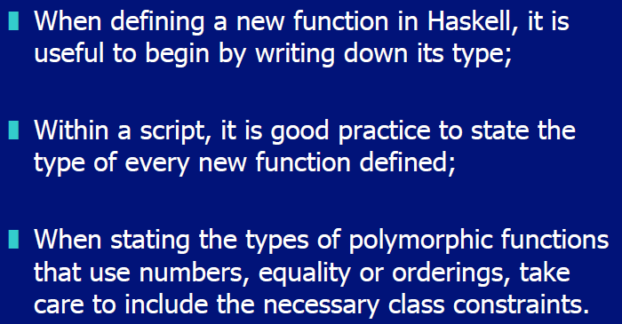

# Woche 4

## Typeclasses

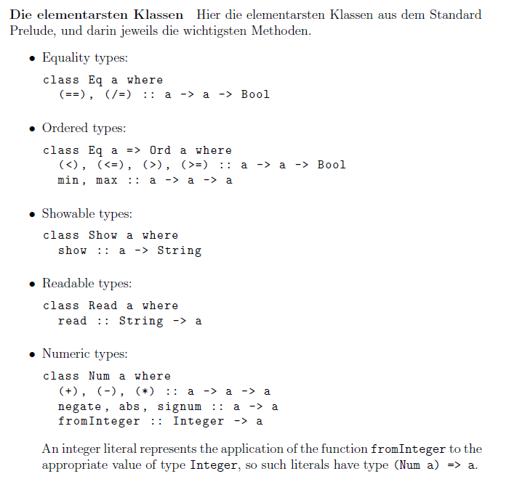

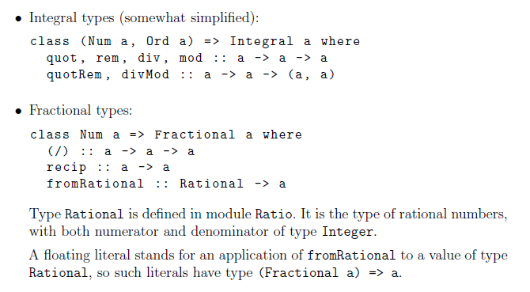

# Woche 5

## Conditional Expressions

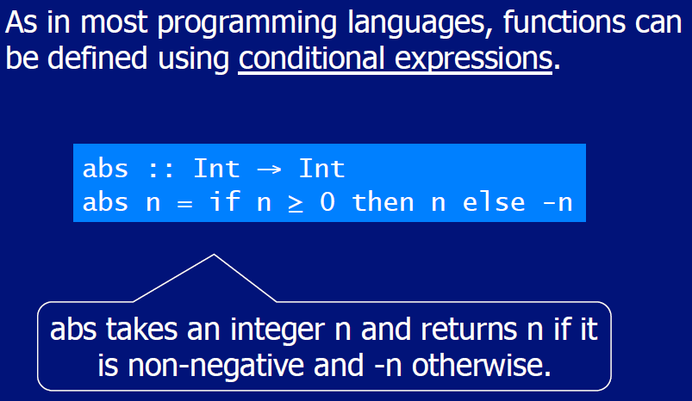

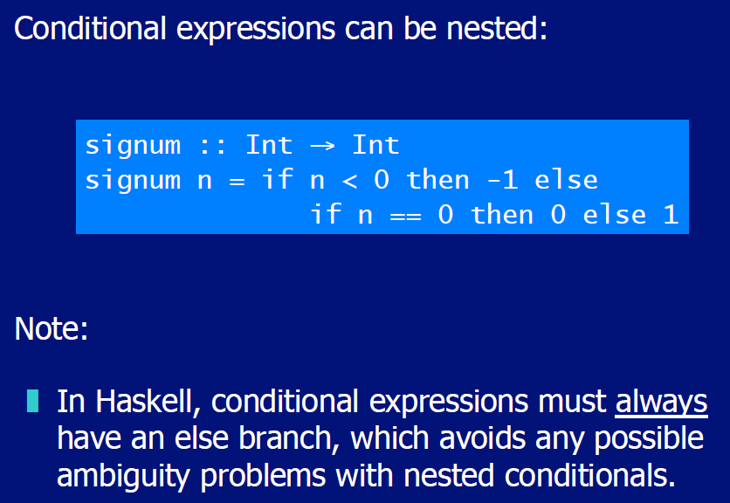

## Guarded Equations

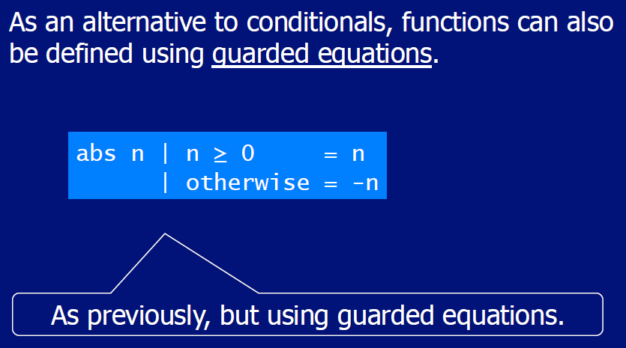

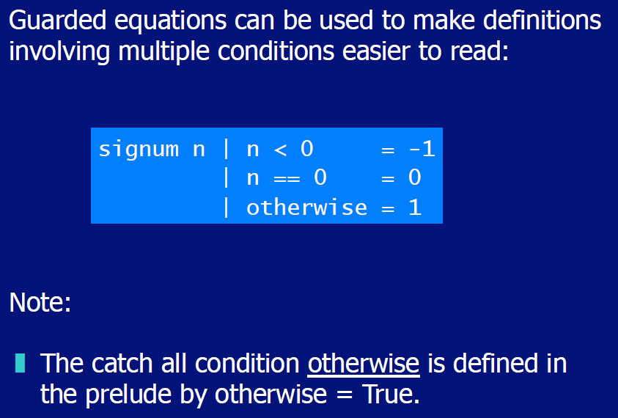

## Pattern Matching

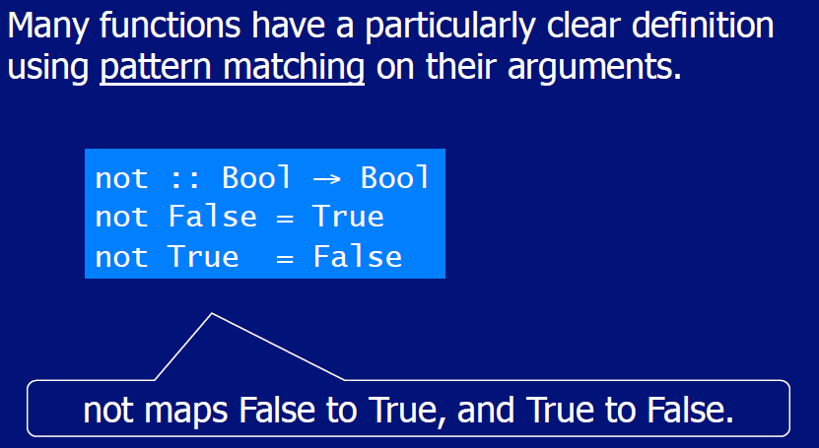

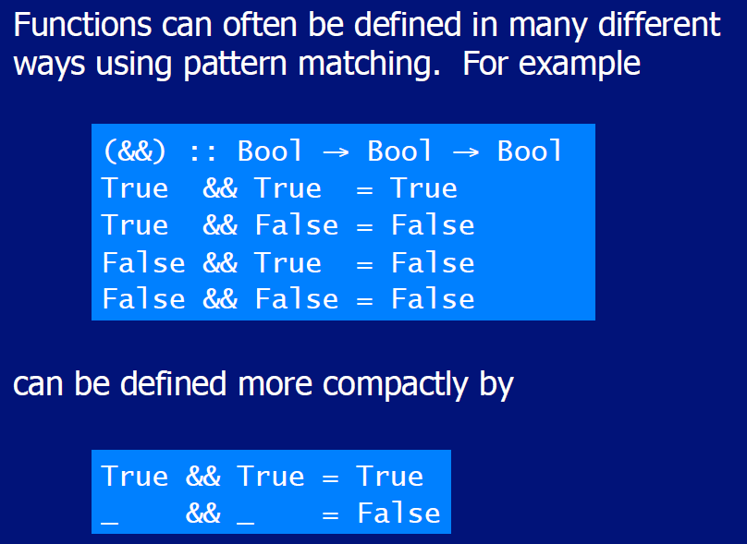

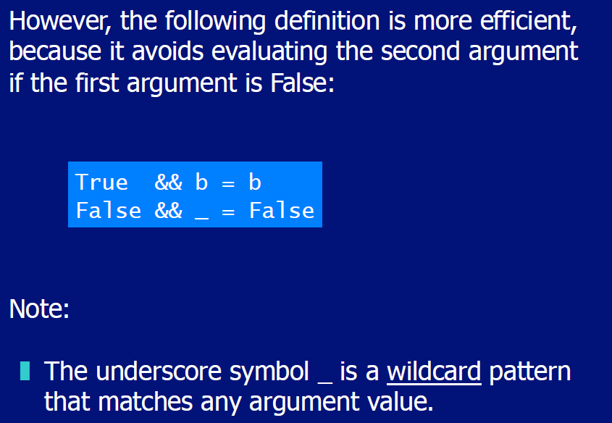

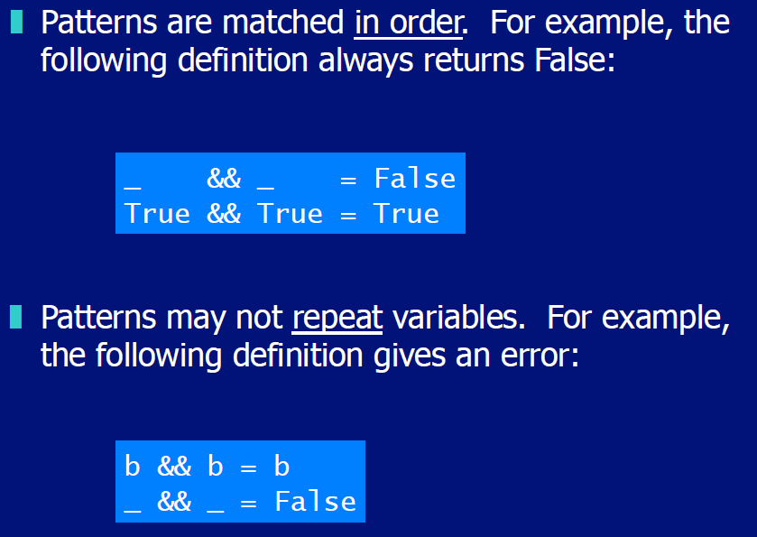

## List Patterns

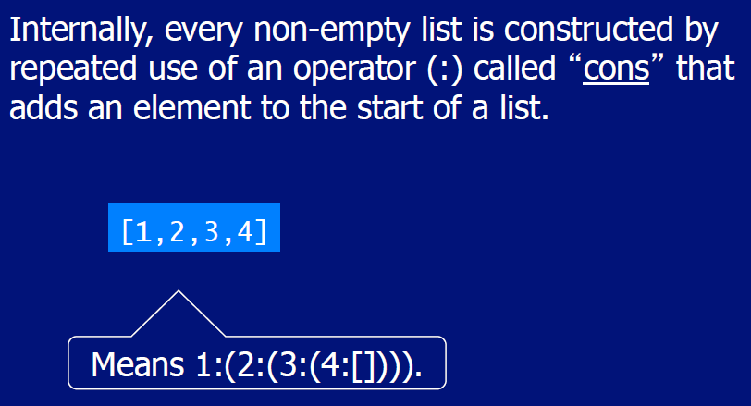

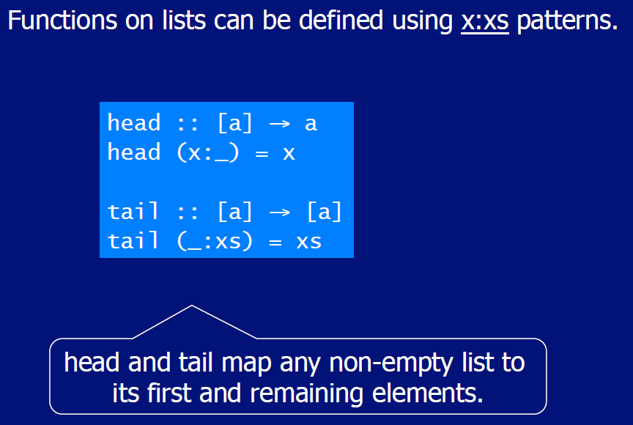

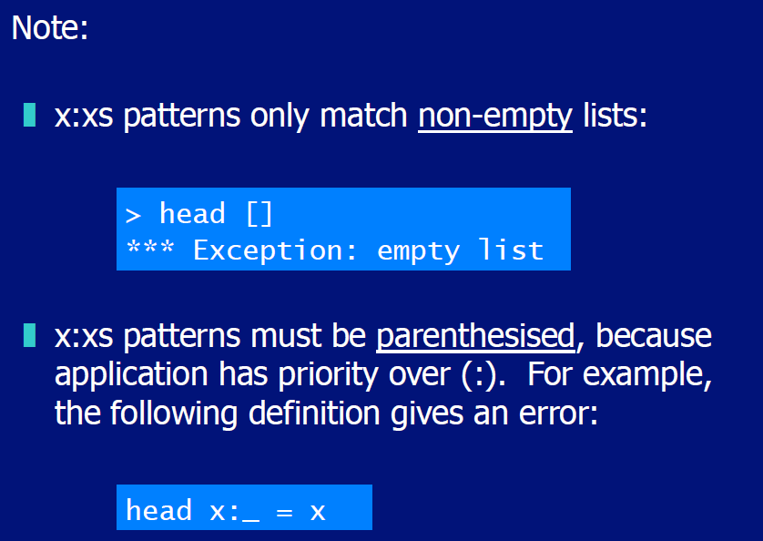

# Woche 6

## Lambda Expressions

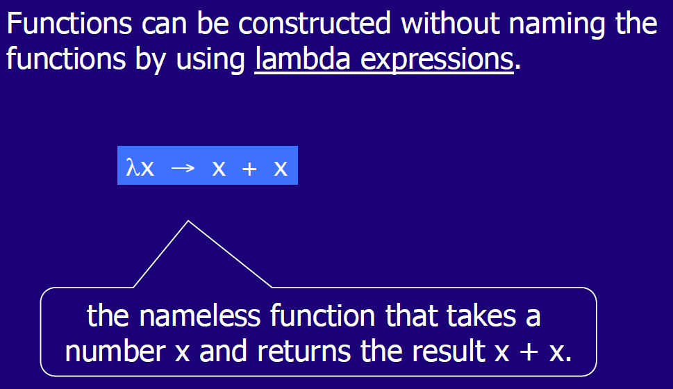

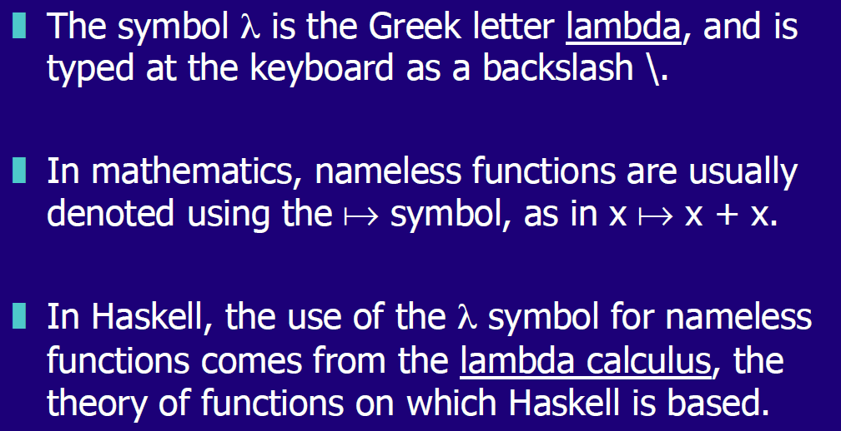

## Why are Lambdas useful

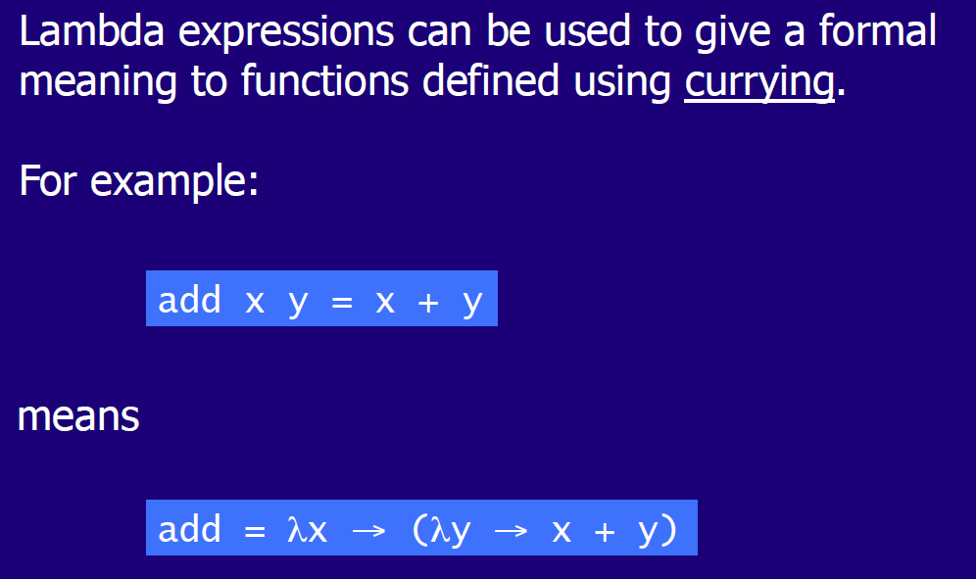

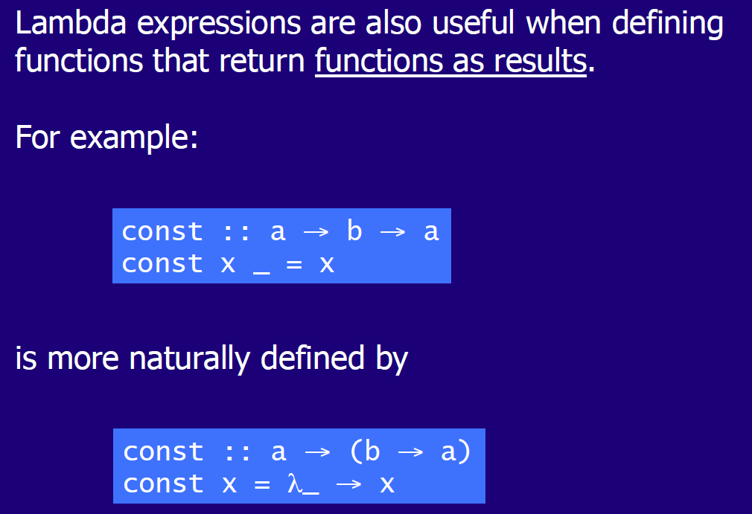

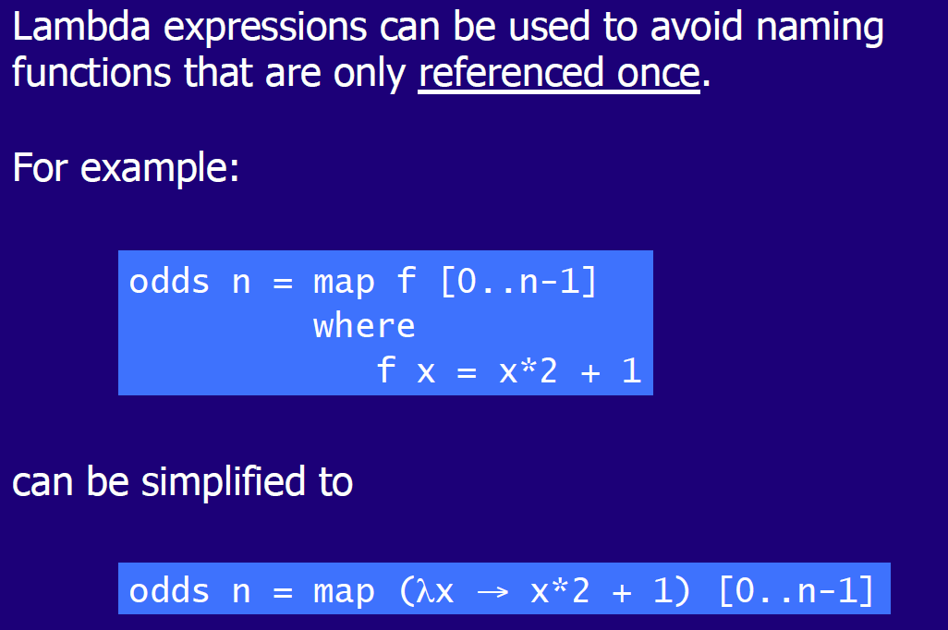

## Operator Sections

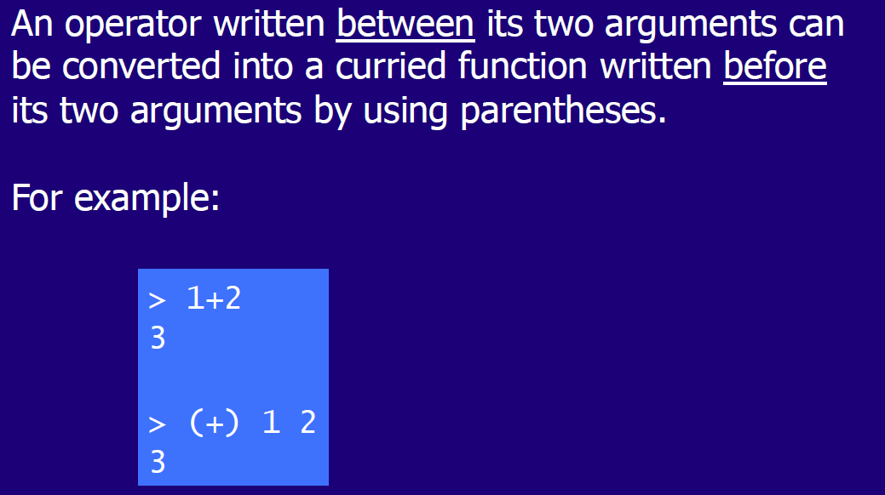

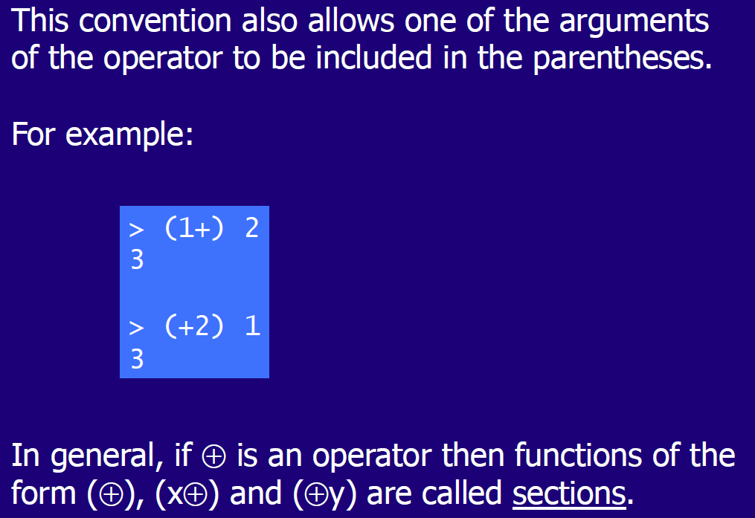

## Why are Sections useful

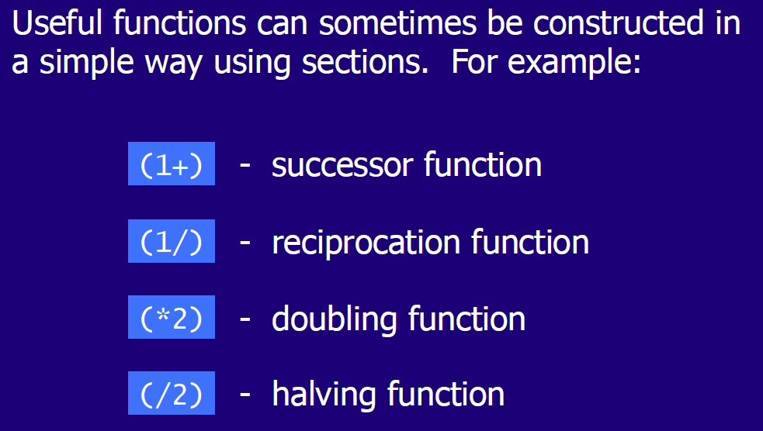

## Set Comprehensions

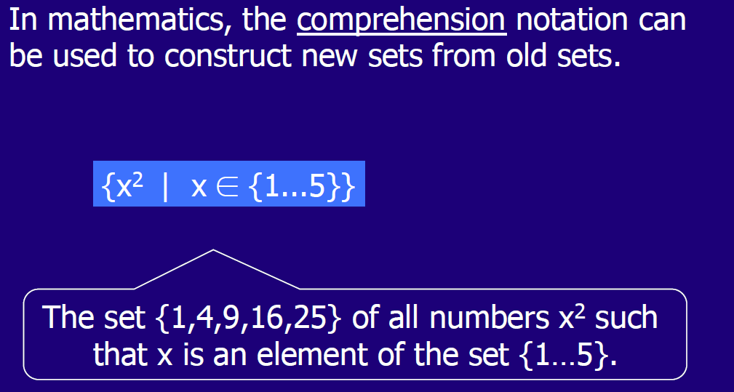

## List Comprehensions

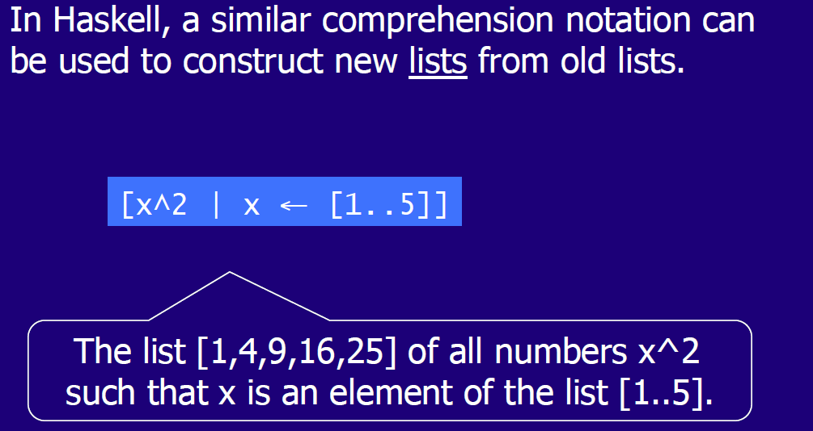

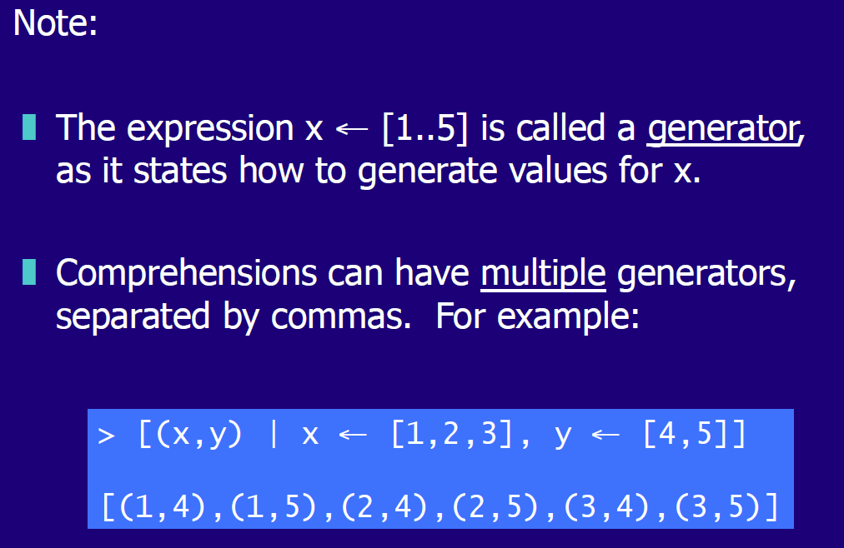

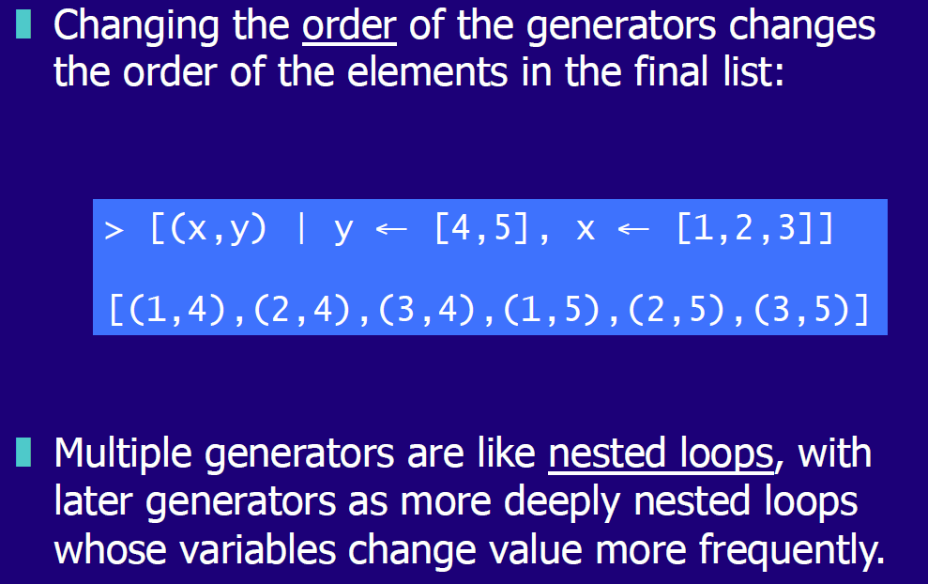

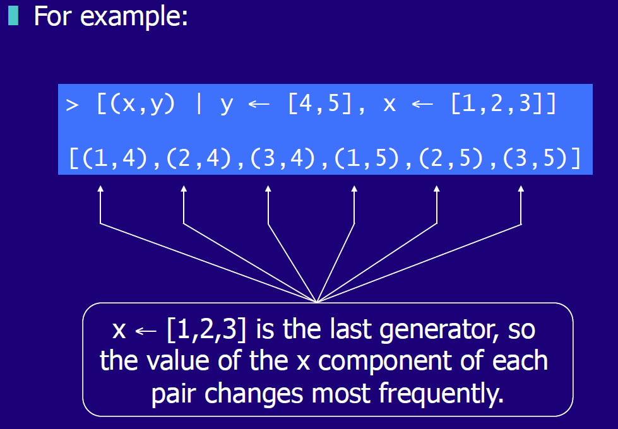

## Dependent Generators

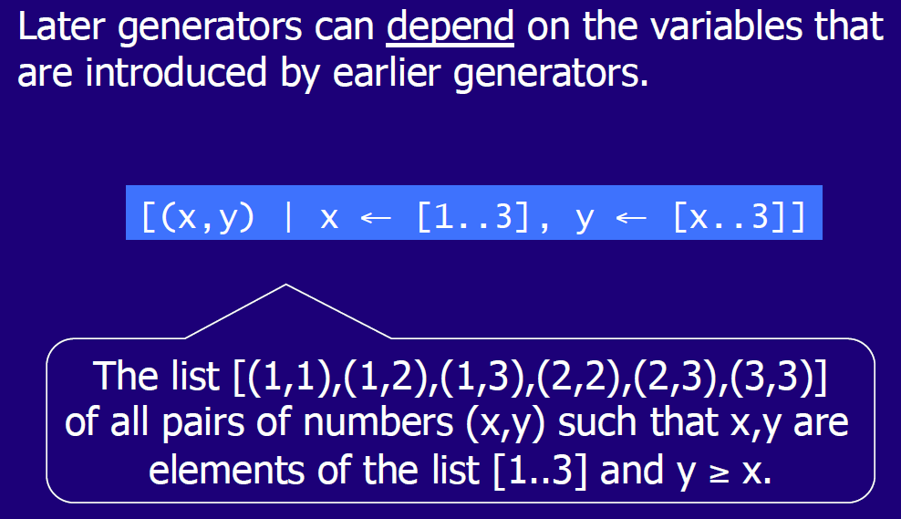

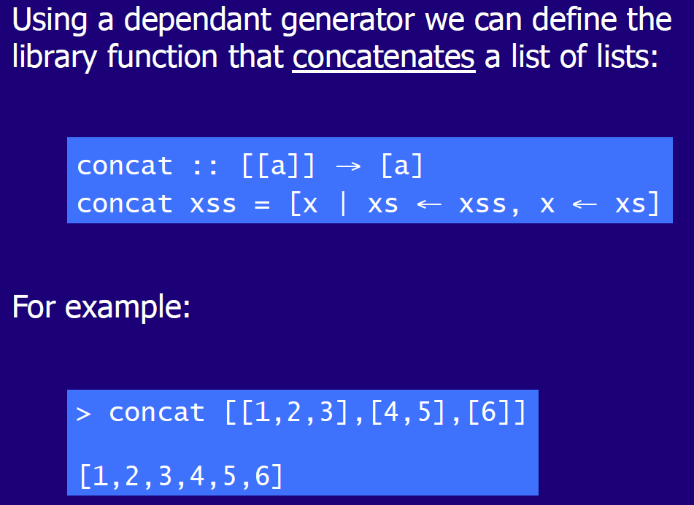

## Guards

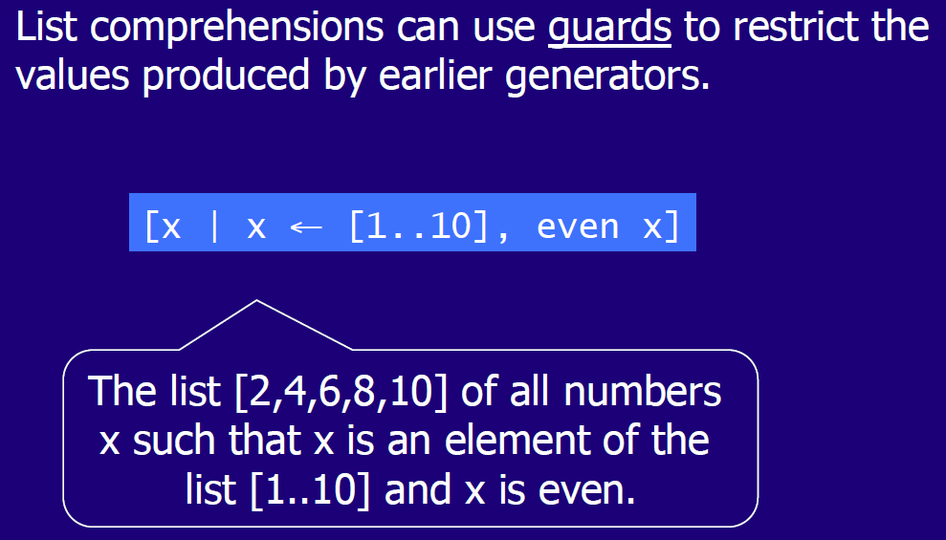

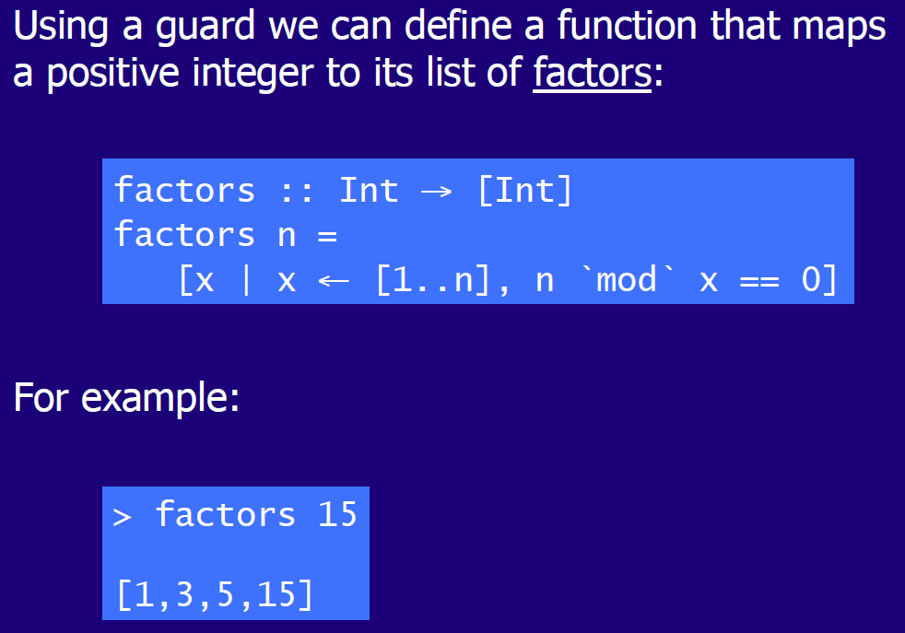

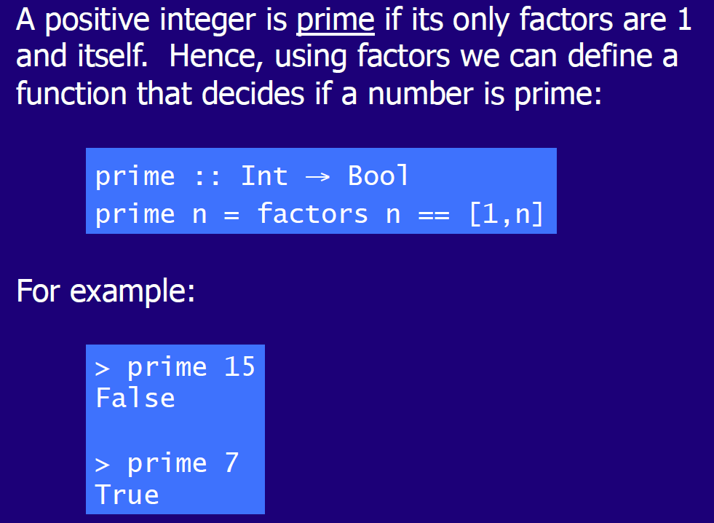

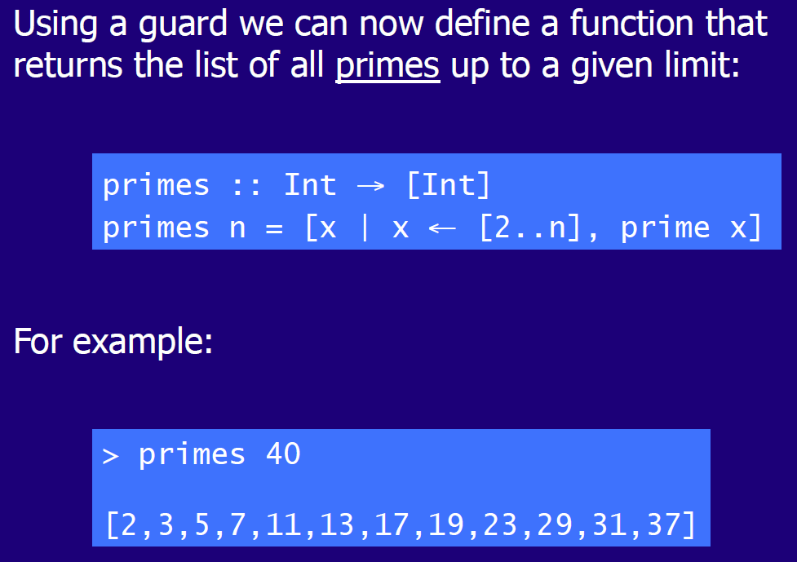

# Woche 7

## Zip Function

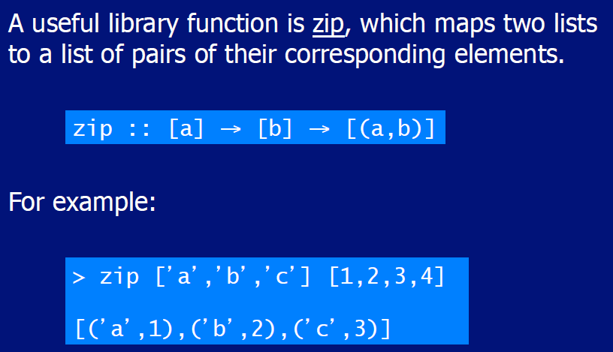

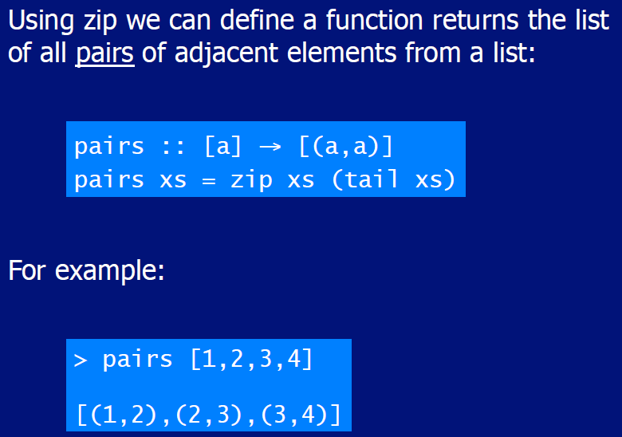

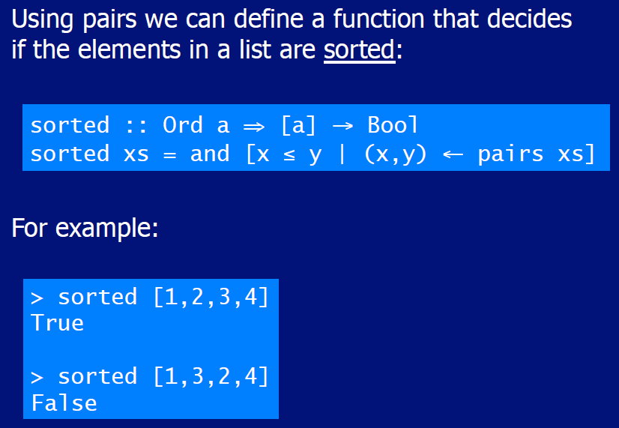

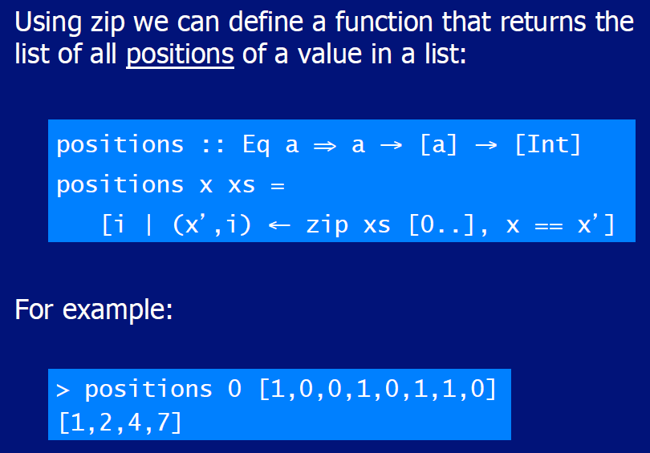

## String Comparison

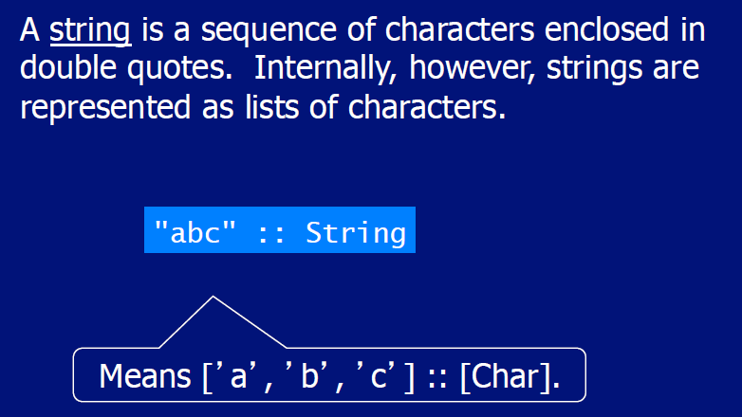

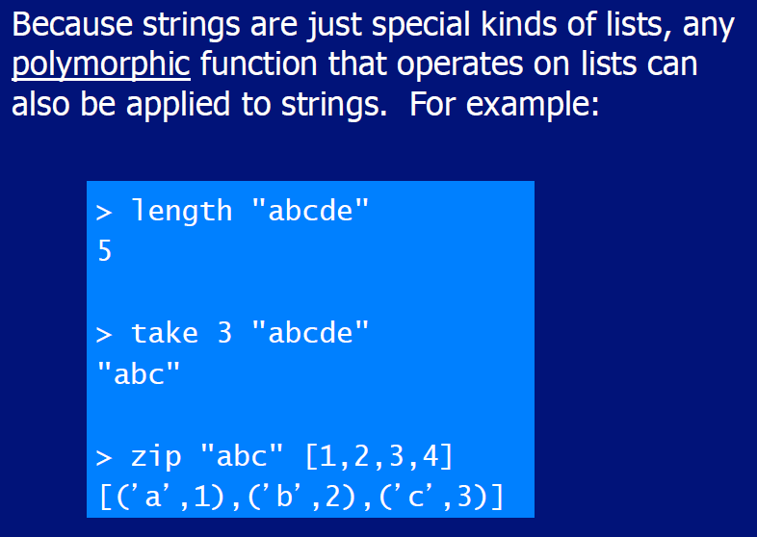

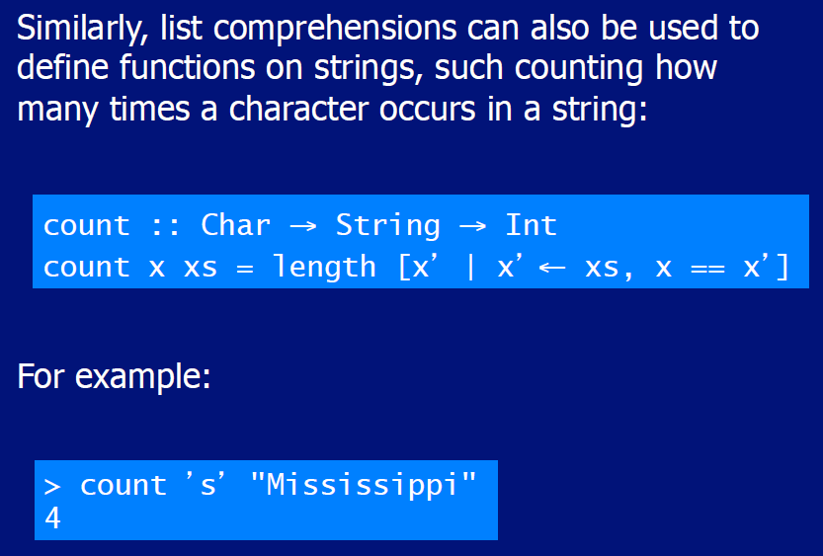

# Woche 8

In Woche 8 fand die erste Prüfung statt und somit fiel der Unterricht aus.

# Woche 9 & 10

## Introduction to Recursion

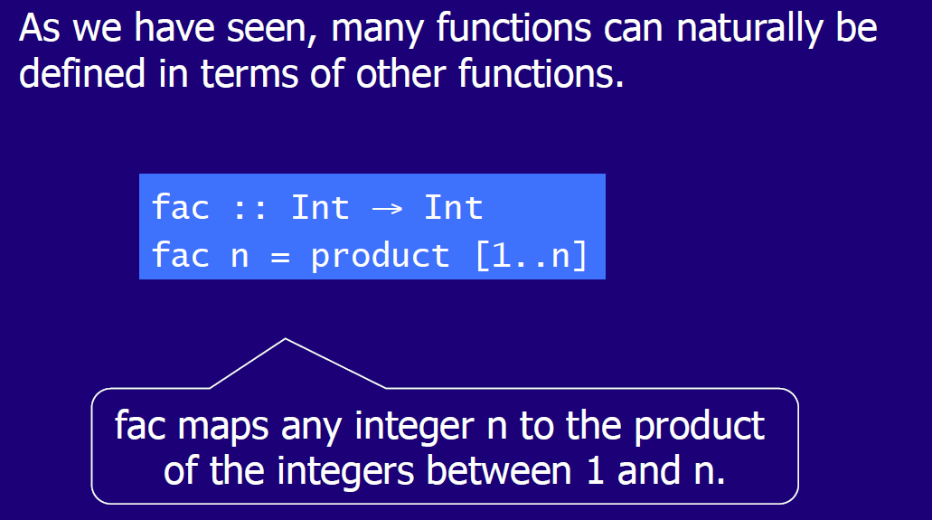

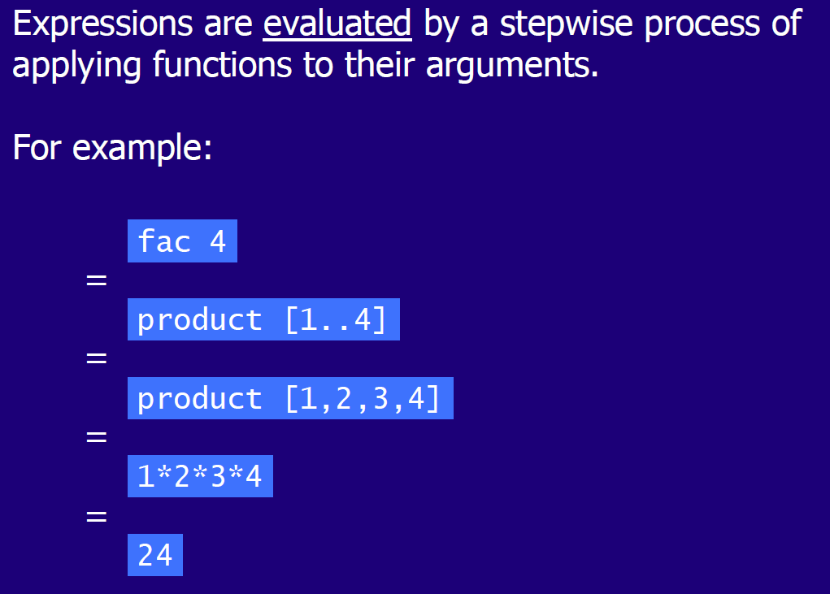

## Recursive Functions

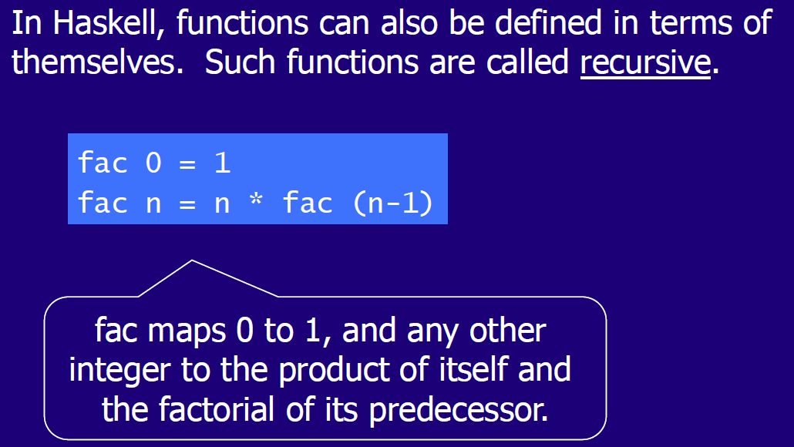

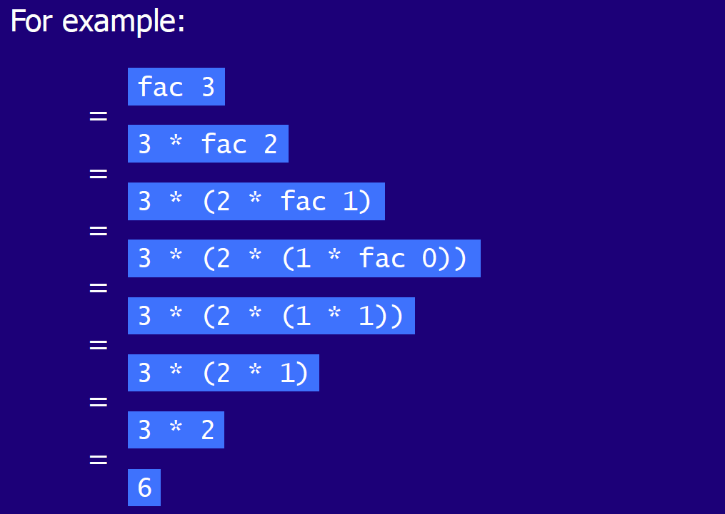

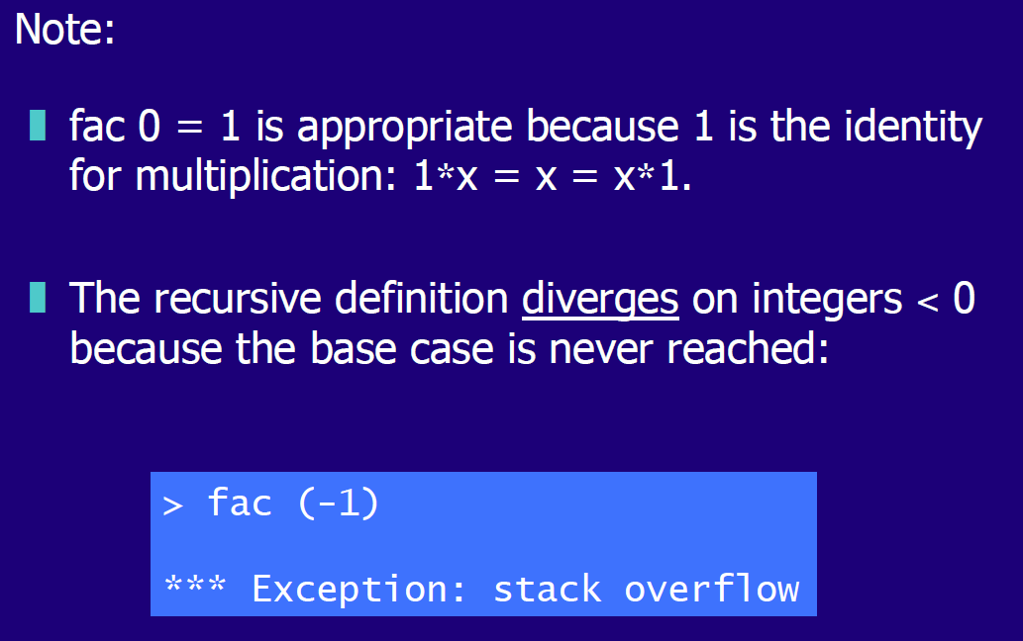

## Why is Recursion useful

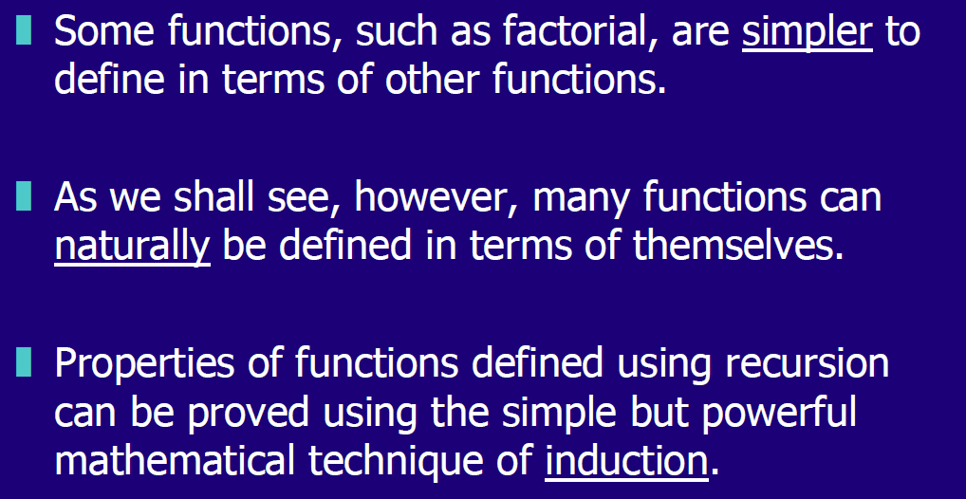

## Recursion on Lists

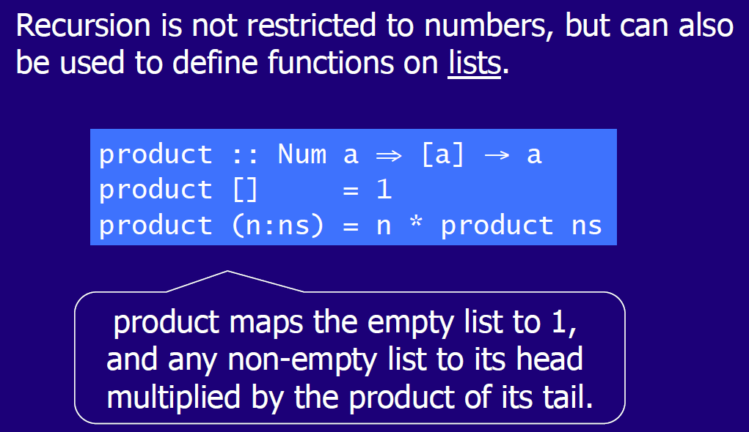

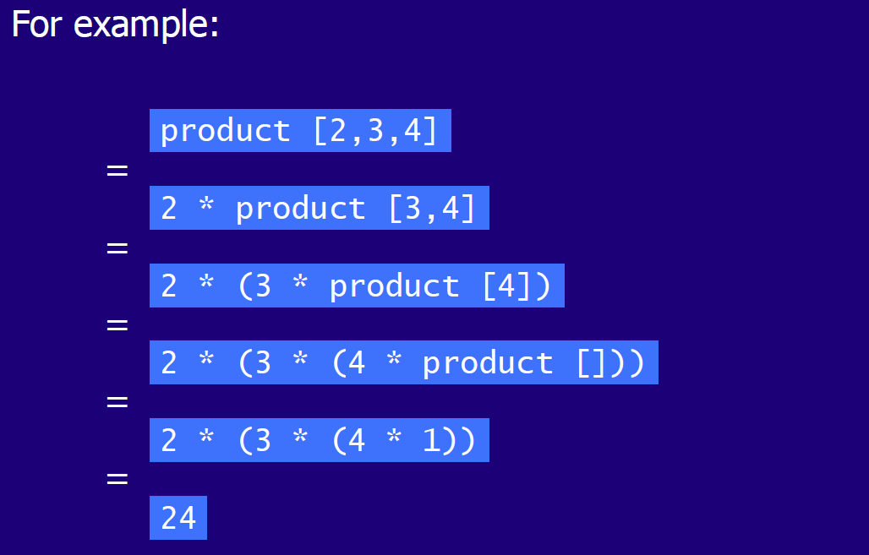

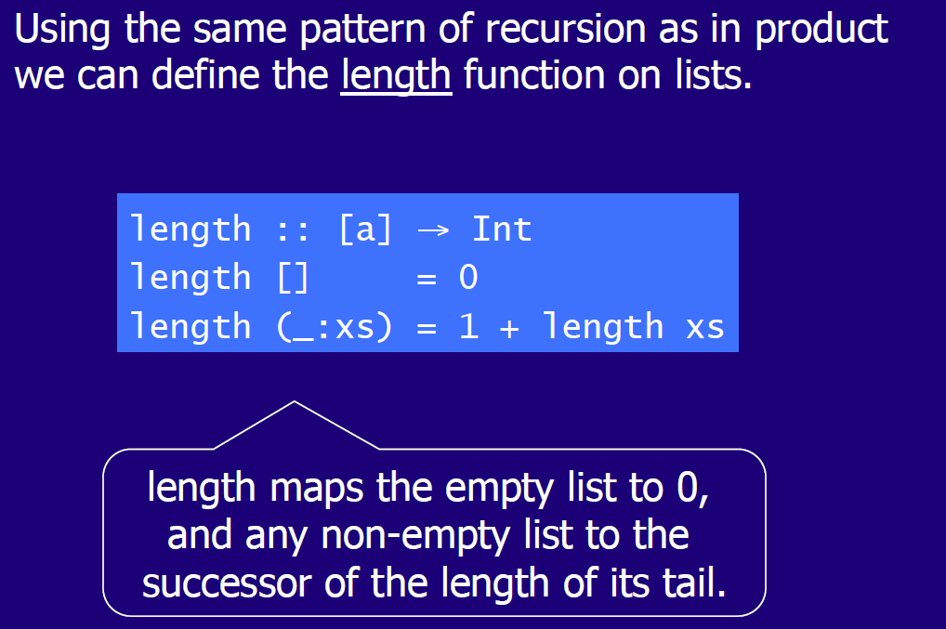

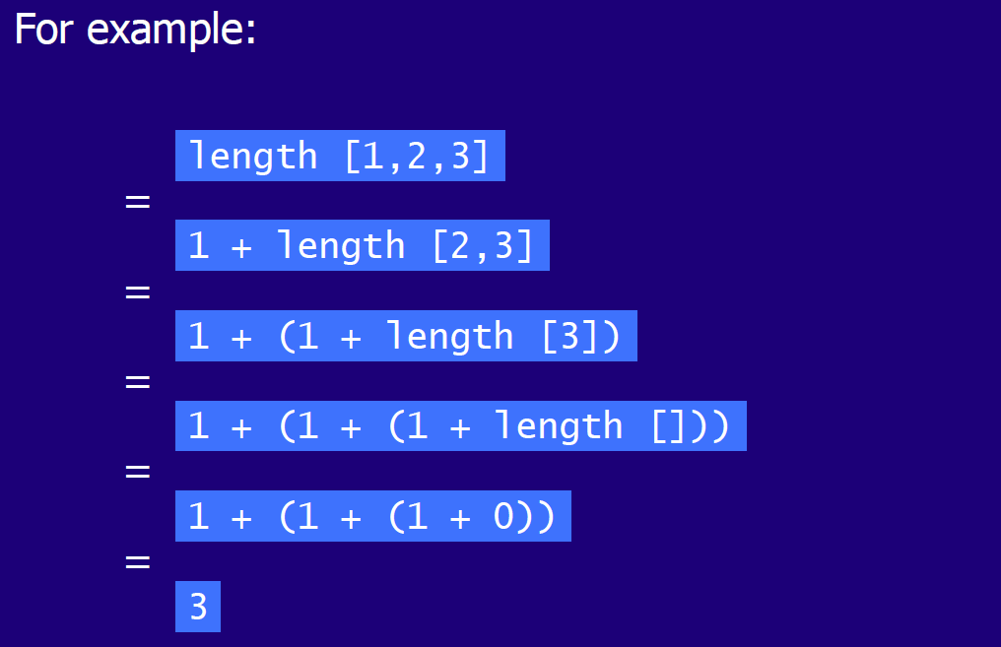

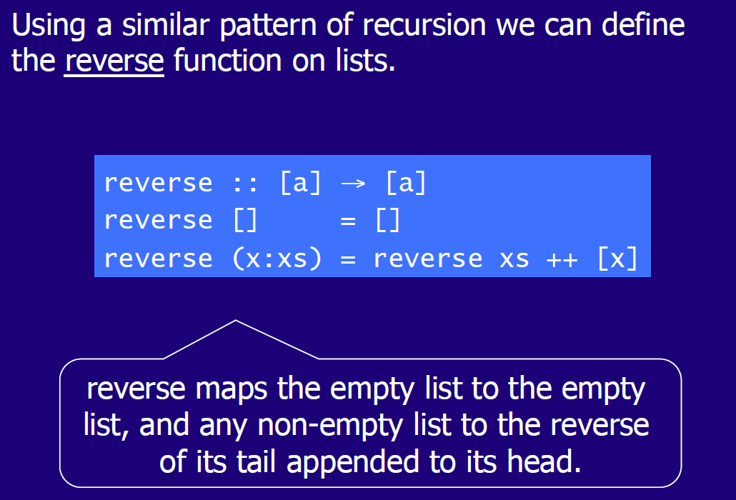

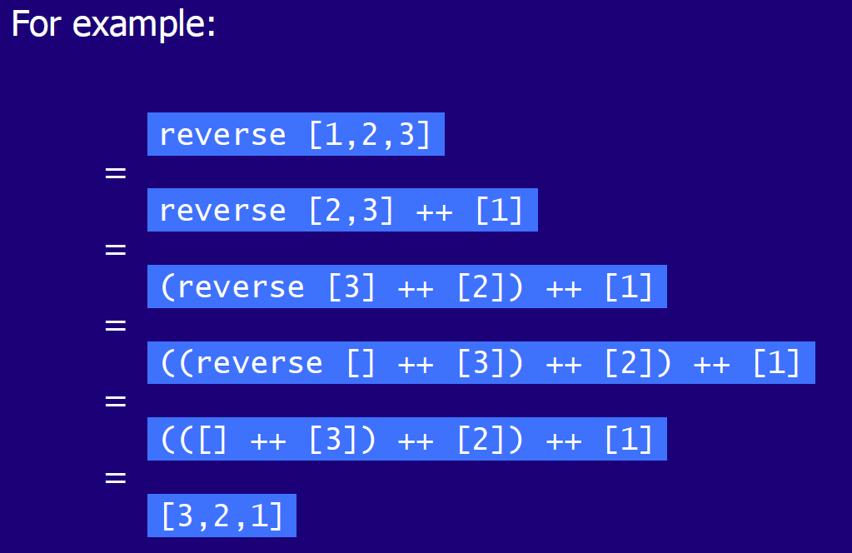

## Multiple Arguments

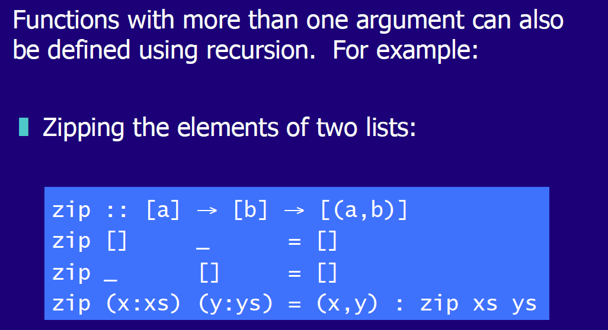

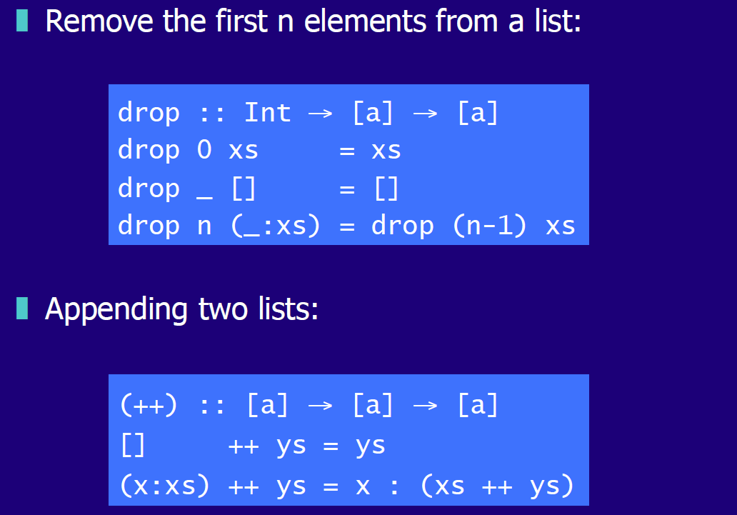

## Quicksort

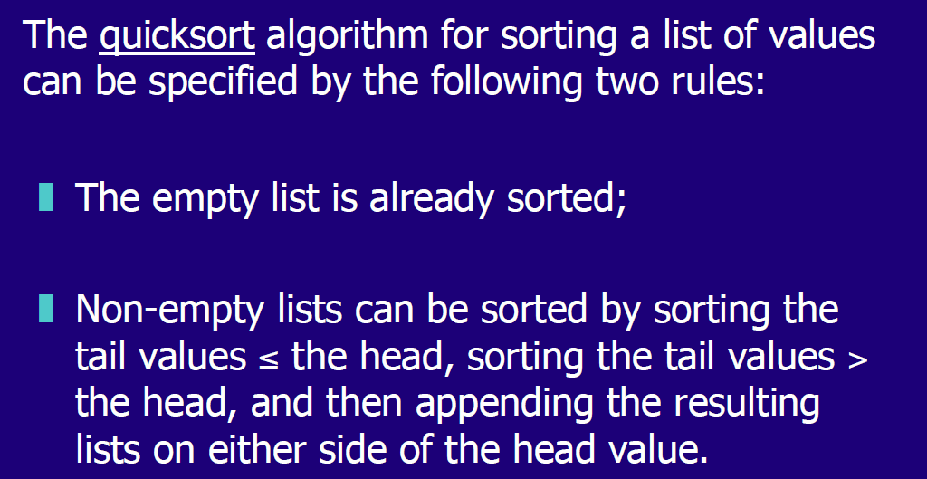

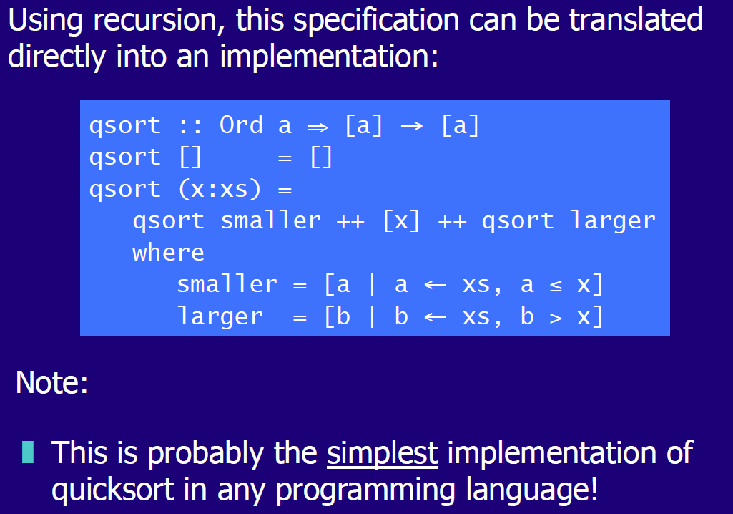

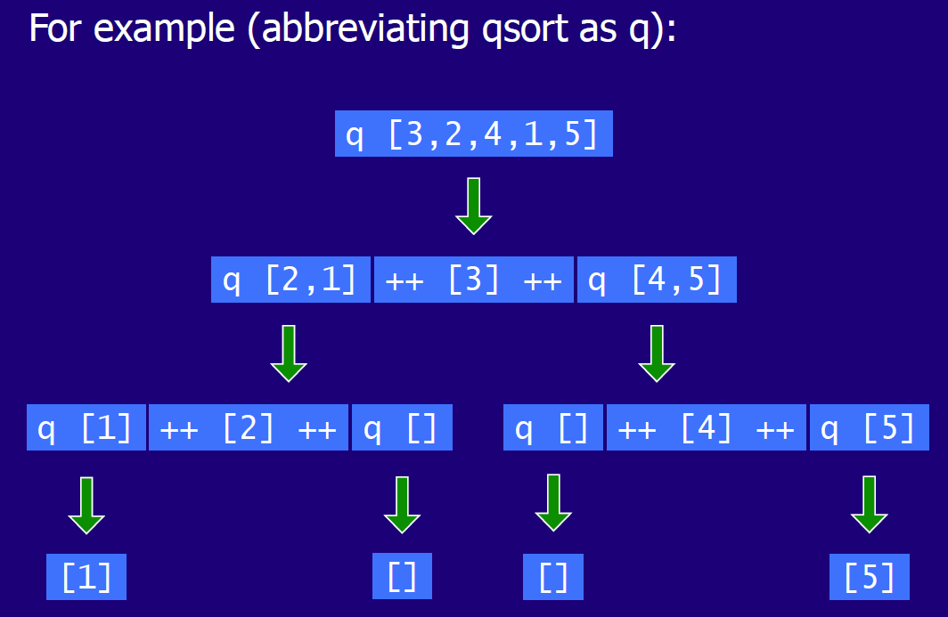

# Woche 11

In Woche 11 fand aufgrund der Projektwoche kein Unterricht statt.

# Woche 12